Kinesiology Tape

Congratulations! You are receiving the same advanced therapeutic procedure that Olympic and professional athletes receive for their pains, misalignments and injuries.

Kinesiology tape was invented by a Japanese chiropractor to help support and strengthen the body’s natural healing properties.

Simon Spine uses KinesioTape as well as RockTape

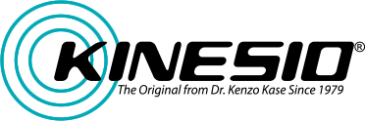

KINESIOLOGY TAPING BENEFITS:

- REDUCES PAIN by causing the body to release Endorphins and Enkephalins (the body's natural pain relievers).

- HELPS ADJUSTMENTS HOLD by gently supporting the area.

- REDUCES SWELLING by improving lymphatic flow.

- REDUCES MUSCLE SPASM by reducing muscle fatigue and over contraction.

KINESIOLOGY TAPING INSTRUCTIONS:

  - Shower and bathe as usual and simply pat the KinesioTape with a towel.

  - Do not rub with a towel. Do not dry with a blow dryer.

  - Ice can be applied over the tape for additional relief.

  - The tape is not magnetic or medicated. However, a very small percentage of patients may experience sensitivity or allergic reaction to the glue. Remove the tape, should any problems develop. Mild itching can be a sign of increased blood flow, and should not be mistaken for an allergic reaction.
  - Leave the tape on as long as you can. It should begin to come off as the outer skin layer naturally sloughs off, about two to seven days.

